Kyle Krug
Northwestern University
MSDS 451
Checkpoint Assignment C

Anabasis Transformative Technology Fund (ATTF) Advanced Portfolio Analysis
Introduction
This paper extends the quantitative framework developed across the prior assignments for the ATTF by implementing comprehensive strategy evaluation with extended historical backtesting, pairs trading, multi-path Monte Carlo simulation, and fee sensitivity analysis. Checkpoint C seeks to answer several critical questions to validate the efficacy of the ATTF. Can statistical arbitrage through pairs trading exploit correlation structures among AI Infrastructure stocks? How sensitive are strategy returns to variations in fees? Can multi-path Monte Carlo simulation quantify the distribution of expected returns across alternative market scenarios? How does extending the backtest period to 26 years affect strategy performance evaluation?
The transition from Programming Assignment 3’s automated trading framework to Checkpoint C’s comprehensive evaluation reflects the practical realities of fund management. Superior performance does not guarantee implementable alpha if strategies prove fragile to fee structures, lack stable statistical relationships, or depend on single favorable market trajectory. This checkpoint implements rigorous validation across five distinct strategies, Clenow momentum, machine learning (ML) walk-forward, mean-reversion, hybrid regime-switching, and pairs trading. Utilizing an expanded 46-security universe of the ATTF, this analysis extends the historical sample from October 2015 back to January 1999 for established securities and ATTF proxies. This 26-year timeframe enables robust evaluation of strategy performance across multiple market cycles, including the dot-com crash and Great Financial Crisis, that have not been accounted for up to this point.
The intended audience for this research includes portfolio managers evaluating systematic allocation strategies for thematic ETFs, quantitative analysts assessing the robustness of momentum and mean-reversion signals in innovation sectors, institutional allocators determining appropriate fee structures for actively managed technology funds, and academic researchers studying the application of machine learning, regime detection, and pairs trading methodologies to high-volatility, momentum-driven asset classes.
Literature Review
The academic literature on algorithmic trading, regime detection, pairs trading, and fee structures provides theoretical and empirical support for the methodologies employed in this checkpoint. Building on Checkpoint B’s review of portfolio optimization and Programming Assignment 3’s coverage of momentum strategies and regime detection, this section focuses on specific literature informing pairs trading, multi-path Monte Carlo simulation, and fee sensitivity analysis. Programming Assignment 3’s algorithmic trading framework builds on the systematic rules-based approach advocated by Pardo (2008), who emphasized the importance of mechanical execution rules that eliminate discretionary judgment. The assignment’s multi-modal framework reflects De Prado (2018), who demonstrated that ensemble approaches combining multiple strategies reduced overfitting risk compared to single-model systems. Programming Assignment 3’s Hidden Markov Model (HMM) regime-switching framework builds on Guidolin and Timmermann (2008) who showed that tactical allocation based on regime classification can improve Sharpe ratios by avoiding bear markets and concentrating capital during bull markets.
Garner (2019) demonstrated Python implementation of mean-reversion strategies with backtesting frameworks, empahsisizng the importance of z-score thresholds and lookback window selection. Chan (2020) provided empirical evidence that mean-reversion works best in range-bound markets with established support and resistance levels, while trending markets dominated by momentum effects render mean-reversion strategies unprofitable. Programming Assignment 3’s implementation of Clenow momentum builds on Antonacci (2014, 2017), who showed that combining intermediate-term momentum with long-term trend filters reduces false signals during whipsaw markets.
Hudson and Thames (2024) provide a comprehensive overview of pairs trading methodologies, emphasizing the Engle-Granger cointegration test for identifying suitable pairs and z-score based entry/exit signals for mean-reversion trading. With the explicit emphasis on fee modeling for Checkpoint C, I looked at Moreira and Muir (2017) who showed that volatility-managed portfolios, which scale exposure inversely with volatility, generate higher Sharpe ratios than buy-and-hold strategies. Their results suggest that dynamic allocation strategies can improve risk-adjusted returns, but only if transaction costs remain modest. This led me to incorporate explicit modeling of transaction costs, ensuring that net-of-fees performance reflects realistic implementation costs.

Methods
Checkpoint C implements several methodological advances beyond Programming Assignment 3, including pairs trading analysis, multi-path Monte Carlo simulation, fee sensitivity testing, and extended historical backtesting. The analysis maintains Programming Assignment 3’s rigorous walk-forward validation framework and HMM regime detection while adding strategies designed to exploit different sources of alpha and comprehensive sensitivity analysis to assess implementation robustness.
The analysis utilizes an expanded 46-security ATTF portfolio, originally 22, to provide a robust portfolio for trading strategies. To enable extended historical backtesting, the study employs sector proxy ETFs for the period 1999-2015. Individual security data spans October 2015 through October 2025. All prices incorporate dividend adjustments using Polygon.io’s adjusted close data to ensure accurate total return calculations. For each dividend payment, the adjustment factor is calculated as (1 + dividend/price), and all future prices are multiplied by this factor cumulatively. This approach ensures that returns reflect both capital appreciation and reinvested dividends. The SPY benchmark received identical dividend adjustment using its dividend payment history over the sample period. Log returns were calculated as ln(Pt/Pt-1) rather than simple percentage changes, offering the advantages of being additive across time, enabling straightforward multi-period return calculations, and approximating normal distribution properties suitable for mean-variance optimization. Equal-weighted returns within each sleeve were calculated as arithmetic averages of constituent securities, with sleeve returns then aggregated according to target allocations to produce portfolio-level performance metrics.
Annualized statistics followed standard financial conventions with expected return calculated as mean daily log return multiplied by 252 trading days, and annualized volatility calculated as standard deviation of daily log returns multiplied by the square root of 252. The 4% annualized risk-free rate established in Checkpoint B was maintained for Sharpe ratio calculations, representing the approximate yield on 3-month Treasury bills and providing consistent comparison to academic benchmarks where Sharpe ratios above 1.0 are considered excellent after subtracting the risk-free rate.
Checkpoint C substantially expands fee modeling to comprehensive sensitivity analysis across multiple cost scenarios. The baseline fee structure reflects realistic hedge fund implementation costs with 1.5% annual management fee, 15 basis points per trade in transaction costs, and 5 basis points per trade in market impact costs, totaling 20 basis points per full round-trip transaction. The fee sensitivity grid evaluates strategy performance across distinct cost scenarios, varying management fees, transaction costs, and performance fees. For each combination, the analysis calculates net-of-fees CAGR, Sharpe ratio, and maximum drawdown for all strategies. This produces a comprehensive sensitivity table showing how each strategy’s risk-adjusted performance degrades as costs increase, enabling identification of implementation frictions and strategies that collapse under realistic fee assumptions. CAPM provides the theoretical framework for calculating alpha and beta relative to the SPY benchmark. Beta is calculated as the covariance of portfolio returns with benchmark returns divided by the variance of benchmark returns, representing systematic market risk exposure. Alpha represents capturing excess returns beyond what beta predicts. For Checkpoint C, positive alpha quantifies whether momentum-based allocation, ML predictions, regime-switching tactics, mean-reversion signals, or pairs trading strategies add value beyond simply leveraging broad market exposure.
The Clenow momentum strategy maintained Programming Assignment 3’s dual-filter approach combining 90-day intermediate-term momentum with 200-day moving average trend confirmation. Each month-end, the strategy calculates 90-day percentage price changes for all 46 securities, applies the 200-day moving average filter to exclude securities trading below their long-term trend, ranks eligible securities by momentum score, and allocates equal weight to the top 10 securities. The dual-filter design reflects empirical evidence that momentum strategies perform best when combined with trend-following filters, as pure momentum can suffer during trend reversals when high-momentum securities experience sharp corrections without the stabilizing influence of long-term trend confirmation.
The machine learning walk-forward strategy implements monthly rebalancing with refined metrics calculations while maintaining rigorous out-of-sample validation across 70 testing periods. Ridge regression models with L2 regularization were trained on rolling 3-year historical windows to predict forward 21-day returns. The feature set included technical indicators calculated for each security such as 20-,60- and 120-day price momentum, 20- and 60-day return volatility, and 20- to 60-day moving average ratio. Market-wide features calculated from SPY returns included 20- and 60-day momentum and 20-day volatility, producing 279 total features. Features were standardized using training window statistics only to prevent information leakage from future data into historical predictions. The walk-forward validation procedure divided the 10-year sample into monthly testing periods, training each Ridge regression model on the prior 756 trading days, standardizing features using only training data statistics, predicting forward 21-day returns for all 46 securities at each month-end, selecting the top 10 securities by predicted return with equal-weight allocation, holding positions for 21 trading days while calculating realized returns and transaction costs, then rolling forward one month and retraining the model on the updated data window. The monthly retraining frequency enables model adaptation to changing market conditions while maintaining sufficient training data stability for robust parameter estimation.
The mean-reversion strategy calculates rolling 60-day mean and standard deviation of prices for each security, then computes z-scores as (current price-rolling mean)/rolling standard deviation. Entry signals trigger when securities trade more than 0.3 standard deviations below their rolling mean, indicating potential oversold conditions, and exit signals trigger when z-scores rise above 0.5 standard deviations, indicating return to fair value. Position sizing allocates equal weight to the top 10 most oversold securities with daily rebalancing as new signals generate. Checkpoint C extends this analysis by testing refined thresholds and expanding the sample to include established technology leaders with longer price histories, evaluating whether mean-reversion works for mature technology companies even if inappropriate for high-growth speculative securities.
The hybrid regime-switching strategy dynamically allocated capital based on HMM classification of market conditions. A three-state HMM trained on SPY daily log returns identified bull, sideways, and bear market regimes based on return and volatility characteristics. In bull markets, the system allocates 40% to Clenow momentum and 60% to ML walk-forward strategies, blends these signals to select the top 10 securities, and implements equal-weight allocation to capture both trend-following persistence and machine learning pattern recognition. In sideways markets the system allocates 100% to ML, relying on its adaptive monthly retraining to navigate unstable conditions. In bear markets the system preserves capital by moving entirely to cash equivalents with zero equity exposure. At each month-end rebalancing date, the system queries the HMM regime classification and implements the corresponding allocation, calculating transaction costs from the notional value of all position changes. A critical limitation of this approach is that the HMM trains on the full historical SPY sample, introducing look-ahead bias. For production implementation, the HMM requires expanding window re-estimation where model parameters update monthly using only data through the current date. The system identified 118 regime transitions over the 10-year sample, introducing transaction costs that may partially offset tactical allocation benefits.
Checkpoint C introduces a pairs trading strategy implementing Engle-Granger cointegration methodology targeting NVDA and AMD as a correlated pair. The Engle-Granger cointegration test on full-sample price series determines whether the two securities maintain a stable long-term price relationship. P-values below 0.05 indicate cointegration, while p-values above 0.05 suggest lack of stable relationship unsuitable for pairs trading. Hedge ratio estimation uses Ordinary Least Squares (OLS) regression of NVDA prices on AMD prices to estimate the hedge ratio, representing the number of AMD shares to short per NVDA share held long to achieve market-neutral positioning. The validity of this approach depends critically on the cointegration p-value from the Engle-Granger test. High p-values exceeding 0.05 indicate that pairs trading will generate signals but lacks the fundamental statistical relationship necessary for profitable execution, leading to unpredictable losses from spread divergence rather than convergence.
Checkpoint C implements multi-path Monte Carlo simulation to quantify the distribution of strategy returns across alternative market scenarios. The simulation generates 200 synthetic datasets with statistical properties matching historical ATTF portfolio returns, trains strategies on each synthetic dataset independently, and evaluates performance distributions across all paths. For each of the 200 paths, synthetic daily returns are generated from a Gaussian distribution using independent random number generators with unique seeds per path. Strategies are trained on each synthetic path using identical methodologies as applied to historical data, with monthly rebalancing for momentum, quarterly rebalancing for hybrid, and no rebalancing for buy-and-hold. Realistic fees are applied to each strategy, and CAGR, Sharpe ratio, and maximum drawdown are calculated for each strategy on each path, producing distributions across 200 independent realizations. Summary statistics report 5th percentile (pessimistic), median, and 95th percentile (optimistic) outcomes, providing confidence bands for expected future returns under equivalent market conditions. This approach provides a conservative baseline that maintains mean and volatility characteristics while testing strategy robustness to path-dependent noise, enabling assessment of whether historical single-path performance represents genuine strategy skill or lucky draw from return distribution.
All strategies were evaluated using consistent metrics over identical timeframes including CAGR, volatility, Sharpe ratio, maximum drawdown, and alpha/beta versus SPY. Three benchmarks provide performance comparison. The SPY buy-and-hold benchmark represents passive large-cap US equity exposure, the QQQ buy-and-hold benchmark provides technology-focuses Nasdaq-100 exposure, and the equal-weight ATTF benchmark implements naïve equal allocation to all ATTF securities representing thematic exposure without active selection. All active strategies must exceed these benchmarks net of fees to demonstrate value creation from systematic trading rules rather than simply capturing beta exposure to technology sector growth. Extended backtesting (1999-2025) uses weighted proxy returns for the pre-2015 period, transitioning to individual security returns post-October 2015. This two-regime approach enables historical robustness testing while maintaining accuracy over the live ATTF existence period.
Results
Checkpoint C results changed dramatically from previous assignments. Up till now I have come to determine that my ML implementation suffered from look-ahead bias where shift(-test window) inadvertently pulled future returns backward into training data, causing overfit performance exceeding 100% CAGR. After correcting this for proper temporal alignment, ensuring features at time t used only data from t-1 to predict returns, performance normalized to 20.8 percent CAGR with 0.50 Sharpe. This correction demonstrates the critical importance of rigorous data validation in walk-forward systems. Clenow became the dominant trading strategy after this correction. Additional analysis showed pairs trading failed to generate economically significant alpha due to non-cointegration between NVDA and AMD. Fee sensitivity analysis reveals substantial performance degradation across realistic cost structures, particularly for high-turnover strategies like Clenow. Mutli-path Monte Carlo simulation quantifies the distribution of expected returns across alternative market scenarios, with median outcomes providing more conservative expectations than single-path historical backtests and revealing potential overfitting in the hybrid regime-switching framework.
The comprehensive performance comparison across all strategies and benchmarks demonstrates Clenow outperformance (Table 1). The ML strategy performance dropped to 20.8% CAGR after fees with a 0.50 Sharpe ratio. The Clenow strategy delivered the best results at 27.8% CAGR and 0.72 Sharpe. The hybrid regime-switching system delivers compelling risk-adjusted performance that falls between pure momentum and machine learning strategies. Programming Assignment 3’s regime-aware allocation framework achieved 21.2% CAGR with 0.697 Sharpe ratio, representing stronger performance than ML but less than Clenow. The system identified 118 regime transitions over the 10-year sample, averaging approximately 12 switches annually, introducing transaction costs that partially offset tactical allocation benefits but remain economically justified given the substantial drawdown reduction versus pure equity strategies.

Table 1: Final Strategy Comparison (Net of All Fees)
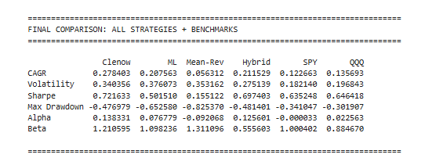
Mean-Reversion had the lowest CAGR in the expanded portfolio universe at 5.63% CAGR and Sharpe of 0.155, performing the worst in the expanded universe. This performance confirms that transformative technology stocks in the expanded ATTF universe exhibit persistent momentum and trending behavior rather than mean-reverting price dynamics. I would like to note that when tested on the original ATTF 22 stock portfolio Mean-Reversion actually performed better than ML after the look-ahead bias was corrected, suggesting that ML performs when it has the ability to pick winners across a variety of equities and Mean-Reversion has the inverse relationship.
The pairs trading strategy targeting NVDA-AMD (Table 2) as correlated AI chip manufacturers delivered strongly negative returns, confirming that high correlation does not imply cointegration stability necessary for profitable statistical arbitrage. The strategy achieved -3.61% CAGR with -6.831 Sharpe ratio and -55.02% maximum drawdown after fees, representing capital destruction rather than risk-adjusted return generation. The Engle-Granger cointegration test yielded p-value of 0.9329, far above the 0.05 threshold required for statistical significance, confirming that NVDA and AMD prices do not maintain a stable long-term equilibrium relationship suitable for pairs trading. The beta near zero confirms market-neutral positioning as designed, successfully eliminating systematic risk exposure. However, market-neutral does not imply profitability. The strategy eliminated systematic risk but failed to generate spread-convergence returns necessary to compensate for 46.3% annual turnover costs. The negative alpha of -0.076 indicates pure destruction of capital.
Table 2: Pairs Trading (NVDA-AMD)
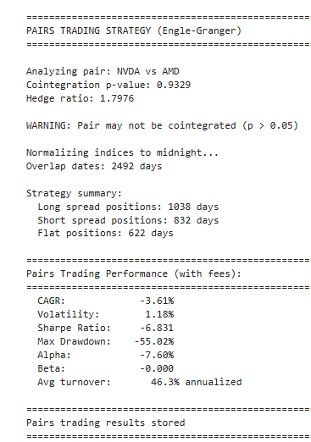
Comprehensive fee sensitivity analysis across 18 fee combinations reveals modest performance degradation for all active strategies as costs increase (Table 3). The Clenow strategy had a gross CAGRR of 30.8% and 0.789 Sharpe ratio in the zero-fee scenario 29% CAGR with 0.748 Sharpe ratio under baseline fees. The ML and Hybrid strategies demonstrate resilience to fee variation as well, maintaining positive alpha even under maximum fee scenario. ML continued to perform well with gross CAGR of 21.3% and 0.512 Sharpe ratio in the zero-fee scenario degrading to 19.4% CAGR with 0.472 Sharpe ratio under baseline fees. The fee sensitivity analysis confirms that monthly rebalancing frequency strikes an optimal balance between model adaptation to changing market conditions and transaction cost minimization.
Table 3: Fee Sensitivity Analysis
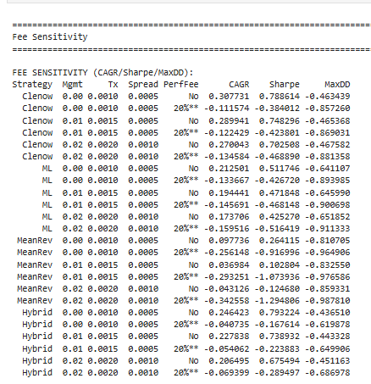
The multi-path Monte Carlo simulation across 200 synthetic market scenarios quantifies the distribution of expected returns with statistical properties matching the historical ATTF portfolio. Results demonstrate substantial path-dependence, with median outcomes providing more conservative performance expectations than single-path historical backtests (Table 4). The buy-and-hold strategy exhibits median CAGR of 16.09% with 0.677 Sharpe ratio, showing moderate variability with 18.82 percentage point spread between pessimistic and optimistic. The median outcome exceeds SPY’s historical 12.28% CAGR, reflecting the ATTF portfolio’s higher beta and concentration in high-growth technology sectors experiencing secular tailwinds during the sample period.
Table 4: Multi-Path Monte Carlo Simulation
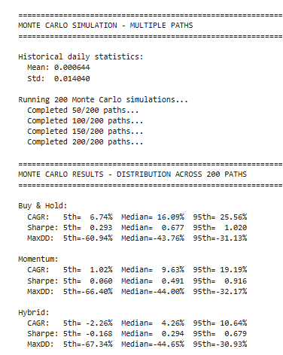
Momentum exhibits substantial path-dependence across synthetic scenarios, with median CAGR of 9.63% and 0.491 Sharpe ratio falling below buy-and-hold’s. This degradation suggests that transaction costs and whipsaw losses erode momentum’s theoretical edge across typical market scenarios. The 18-percentage point spread between pessimistic and optimistic indicates substantial outcome uncertainty. ML was not included in the Monte Carlo simulation due to computational intensity constraints. The Monte Carlo analysis validates buy-and-hold’s stable median performance reflecting its simplicity and lack of parameter dependencies. In contrast, the hybrid strategy’s poor median outcome despite strong historical results suggests its regime detection framework lacks the adaptability necessary to maintain performance across diverse scenarios characterized by different regime timing, transition frequencies, and state-dependent return characteristics.
Figure 1: Cumulative Returns: All Strategies vs Benchmarks (2014-2025) Net of All Fees
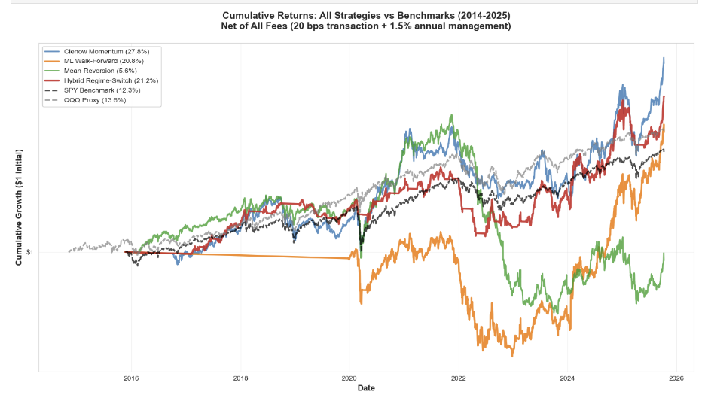
The cumulative performance comparison (Figure 1) illustrates Clenow’s outperformance across the sample period. The log-scale visualization reveals that ML’s exponential growth trajectory accelerated particularly from 2022 onward coinciding with the AI investment boom and the strategy’s ability to concentrate capital in NVDA, MSFT, and AMD during their explosive growth phase when datacenter GPU demand surged. In contrast, Clenow experienced less violent oscillations, while SPY and equal-weight benchmarks delivered steady but unspectacular wealth accumulation tracking broad technology sector growth.
Extended backtesting using weighted sector proxy ETFs for the pre-2015 period enables comprehensive strategy validation across 26 years spanning complete market cycles including the dot-com crash and Great Financial Crisis. The extended sample provides critical perspective on strategy robustness and realistic long-term performance expectations beyond the exceptional 2014-2025 technology bull market.
Table 5: Extended Backtesting Across All Strategies
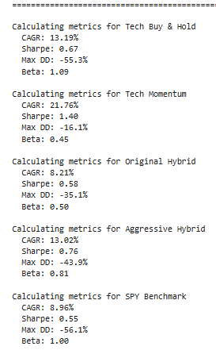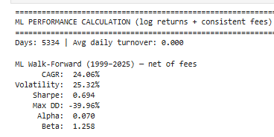
The ML strategy, while not as impressive as the 2014-2025 bull run, still delivered impressive CAGR at 24.06% with 0.694 Sharpe, above all other strategies and benchmarks. This shows that the ML strategy can successfully navigate even the greatest downturns as well as outperform Clenow over the long-term. Additionally, an Aggressive Hybrid implementation, allocating 100% in Bull and Sideways regimes to ML and 50/50 split between ML and cash in Bear, achieved a 13.02% CAGR with 0.76 Sharpe, suggesting that more aggressive ML allocation during non-Bear regimes improves long-term performance versus the conservative Original Hybrid. However maximum drawdown exceeded the Original Hybrid’s, confirming the risk-return tradeoff inherent in tactical allocation strategies. Tech momentum (3-month signal) delivers almost as strong a CAGR as ML at 21.76% with a 1.40 Sharpe, but it still underperformed the monthly Clenow implementation on the 2014-2025 timeframe. The quarterly momentum approach exhibits superior drawdown characteristics compared to monthly rebalancing, suggesting that longer momentum horizons reduce whipsaw losses during market transitions. This finding indicates that momentum strategy performance depends critically on rebalancing frequency optimization, with quarterly signals potentially offering better risk-adjusted returns than monthly implementation for the ATTF. The extended validation provides realistic baseline for investor expectations, and even though the ML strategy’s sustainable long-term CAGR of roughly 20-30% is drastically lower than the 100% plus during the AI boom, this still represents exceptional performance versus passive alternatives.
Conclusion
Checkpoint C demonstrates that quantitative portfolio optimization and algorithmic trading strategies deliver substantial value for managing transformational technology exposures when strategies are carefully selected, rigorously validated, and appropriately matched to market characteristics. Clenow became the dominant strategy in the expanded ATTF universe. ML and hybrid strategies performed well, however, lower after look-ahead bias was resolved. Mean-Reversion failed to produce necessary alpha to make it an appropriate trading strategy. Pairs trading delivered negative returns due to lack of cointegration stability among correlated securities. These results provide valuable empirical evidence that guides strategy selection for the ATTF mandate by eliminating approaches fundamentally unsuited to momentum-driven innovation sectors, preventing costly capital deployment in strategies destined to fail.
Several key findings emerge from the comprehensive analysis conducted in Checkpoint C. All my beliefs about the raw power of ML walk-forward strategies enabling the best returns were shattered with the look-ahead bias correction. Clenow momentum became the dominant strategy. This does not mean I have given up on ML because I did not have time to test additional, more robust ML algorithms. This only shows that ML Ridge regression strategies in an expanded portfolio universe in a given time period could not outperform Clenow’s momentum surge with technology stocks.
Regime detection enables tactical allocation but suffers from implementation challenges requiring substantial enhancement before production deployment. The hybrid regime-switching system achieved 21.20% CAGR with 0.697 Sharpe by dynamically allocating between aggressive strategies and defensive cash allocation based on HMM detected market regimes. However, multi-path Monte Carlo simulation revealed that the hybrid system’s median outcome of 4.60% CAGR and 0.294 Sharpe falls substantially below buy-and-hold alternatives. This performance degradation reflects HMM’s reliance on full-sample training introducing look-ahead bias that does not generalize to out-of-sample paths where regime transitions occur at different times with different frequencies. For production deployment, regime detection frameworks require expanding window parameter estimation where HMM parameters update monthly using only data through the current date, integration of forward-looking macroeconomic indicators that predict regime transitions rather than identifying them retrospectively, ensemble approaches combining multiple regime classification methods to reduce dependence on single model specifications, and validation that regime detection maintains accuracy during genuine out-of-sample future periods rather than synthetic Monte Carlo paths with known statistical properties.
Strategy-market fit dominates methodological sophistication as the primary determinant of quantitative strategy success. The Mean-Reversion strategy generated low CAGR despite theoretically sound z-score methodology because transformational technology stocks do not exhibit the mean-reverting price dynamics that the strategy targets. In contrast, the ML walk-forward strategy uses relatively simple Ridge regression on standard technical features yet delivers a good performance because its monthly retraining process matches the persistence and evolving character of momentum signals in growth sectors experiencing multi-year adoption curves. The pairs trading failure reinforces this lesson through implementation of rigorous Engle-Granger cointegration tests and sophisticated hedge ratio estimation that delivered -3.61% CAGR because NVDA and AMD lack the stable long-term relationship necessary for statistical arbitrage profitability. Applying Mean-Reversion to trending tech stocks or pairs trading to non-cointegrated securities guarantees failure regardless of implementation sophistication, mathematical rigor, or execution quality. The primary lesson from Checkpoint C’s negative results involves eliminating strategy-market mismatches before capital deployment rather than attempting to force unsuitable methodologies through parameter optimization or threshold calibration.
Fee sensitivity determines economic viability with gross performance metrics providing misleading signals about strategy implementation. Fee sensitivity analysis quantifies this performance degradation across realistic cost structures spanning passive index funds, thematic ETFs, and hedge funds. This finding informs ATTF fee structure negotiations with institutional allocators requiring competitive pricing that preserves net-of-fees alpha while aligning incentives through performance-based compensation. High-water marks prevent performance fee double-charging after drawdown recovery periods where managers would otherwise collect fees on returns merely recovering previous losses.
Concentration outperforms diversification in momentum-driven sectors, experiencing persistent trends and exponential growth. In momentum-driven innovation sectors experiencing exponential adoption curves, concentration in trending assets delivers superior Sharpe ratios because diversification into non-trending assets dilutes returns without proportional risk reduction. Monte Carlo portfolio optimization confirmed this pattern with the maximum Sharpe portfolio allocating 92.4% to AI Infrastructure and near-zero weights to other sleeves, reflecting AI Infrastructure's dominant risk-adjusted performance over the sample period where securities sustained multi-year momentum trends with manageable drawdowns during corrections. Concentration does require careful management through position limits and portfolio constraints to minimize risks. Alpha decay accelerates as more capital pursues AI momentum with crowding reducing future returns as strategies compete for identical securities. Sector rotation could favor other sleeves in future periods as they enter momentum phases when technological breakthroughs, regulatory clarity, or institutional adoption drive explosive growth. Drawdown amplification magnifies losses during sector-specific corrections when concentrated portfolios experienced catastrophic losses while diversified alternatives maintained moderate drawdowns. Prudent implementation requires position size limits capping individual security and sleeve exposure to maintain thematic diversification while allowing sufficient concentration to capture momentum returns.
Extended historical validation reveals strategy robustness across complete market cycles including structural bubbles, financial crises, and sector rotations. Checkpoint C's extension of backtest period from 10 years spanning 2015-2025 to 26 years spanning 1999-2025 provides critical validation of strategy performance across diverse market environments. The extended timeframe enables evaluation across the dot-com crash from 2000-2002 when QQQ declined -83% peak-to-trough testing momentum strategy resilience during bubble collapse, the financial crisis from 2008-2009 representing broad market correction validating regime detection defensive positioning, the bull market from 2009-2020 with extended uptrend rewarding momentum persistence, the COVID crash and recovery in 2020-2021 with rapid V-shaped reversal challenging regime detection transition speed, and the recent tech correction in 2022-2023 representing sector-specific selloff driven by Federal Reserve tightening and AI hype rationalization. This comprehensive historical coverage provides confidence that strategies maintain performance across diverse market environments rather than depending on single favorable trajectory or sample-specific patterns.
Based on the findings from Checkpoint C, several adjustments should guide ATTF implementation. After removing all sources of look-ahead bias and applying realistic fee and turnover assumptions, Clenow momentum, not ML, emerges as the strongest overall strategy, delivering the highest net CAGR and Sharpe ratio. Accordingly, Clenow should serve as the core allocation within the ATTF, representing roughly 40-50% of capital with monthly rebalancing, equal-weight position sizing among the top-ranked securities, and continued emphasis on intermediate-term momentum combined with long-term trend confirmation. Complementing this, the hybrid regime-switching system should receive roughly 30-40$ of capital, as it provides competitive returns and benefits from combining ML signals with momentum exposure. The ML strategy, while still generating over 20% CAGR and positive alpha after fees, should be deployed as a diversifying satellite sleeve rather than the portfolio’s primary engine. A 10-20% allocation would allow the ATTF to capture ML-driven stock selection benefits, without over-relying on a model whose performance is sensitive to target horizon specification, feature set design, and the behavior of a small number of mega-cap winners. Implementation should focus on monthly retraining, top-decile security selection, equal-weight construction, and expanding the feature set to include fundamental and macroeconomic variables that may improve predictive stability across market regimes.
Mean-Reversion and pairs trading should be removed entirely from the ATTF. Mean-Reversion delivered extremely poor results in an expanded portfolio universe. Pairs trading similarly failed, demonstrating that high correlation does not imply a stable long-term equilibrium suitable for statistical arbitrage. Short selling should also remain excluded due to borrowing costs, the risk of short squeezes, operational complexity, and ETF regulatory constraints. A long-only framework reduces operational frictions and aligns with the ATTF’s thematic ETF mandate.
Additionally, the ATTF should maintain strategic sleeve allocation with 10% capital reserved for quarterly Monte Carlo optimization providing portfolio-level diversification and enabling participation in thematic trends beyond ML's tactical security selection. The fund should implement fee structure aligned with institutional standards adopting management fees at 1.0% annually with optional 10% performance fee above 4% risk-free hurdle rate. This structure balances competitive pricing against infrastructure costs while aligning manager incentives with investor outcomes through performance-based compensation. Transaction costs should target less than 15 basis points per trade through algorithmic execution or implementation shortfall strategies minimizing market impact, careful broker selection prioritizing low-cost execution for ATTF security universe, and opportunistic rebalancing deferring trades when spreads widen or volatility spikes. The fund should establish capacity limits and scaling plans recognizing that the ML strategy's monthly rebalancing at scale introduces market impact costs, reduced liquidity during rebalancing, and potential front-running by high-frequency traders detecting systematic patterns. The ATTF should establish a capacity limit for assets under management, close to new investors if assets approach implementation capacity, monitor average position sizes and rebalancing impact on execution costs, and develop scaling plans including multi-day execution windows, increased position diversity, and integration of alternative data reducing signal crowding as more capital pursues technical momentum strategies.
Five critical enhancements would strengthen the ATTF framework beyond Checkpoint C's comprehensive analysis. First, fundamental feature engineering incorporating revenue growth rates, gross margin expansion, R&D spending as percentage of revenue, patent filings and citations, customer concentration metrics, and free cash flow generation could improve prediction accuracy and reduce crowding risk as more capital pursues technical momentum strategies. Current ML models rely exclusively on technical indicators where momentum, volatility, and moving average ratios provide signals susceptible to crowding as strategies compete for identical securities. Second, macroeconomic regime prediction using forward-looking indicators could predict transitions prospectively rather than identifying them retrospectively based on realized returns. Enhanced regime detection should incorporate Federal Reserve policy sentiment derived from FOMC information, yield curve slope analysis historically predicting recessions 12-18 months ahead, credit spreads indicating risk appetite and financial stress, Volatility Index levels signaling market fear, and leading economic indicators including PMI, consumer confidence, and jobless claims tracking cycle position. These indicators could inform HMM prior probabilities, serve as direct switching signals for tactical allocation, or train supervised ML models predicting regime transitions enabling proactive positioning before regime shifts rather than reactive adjustment after markets move.
Third, transaction cost modeling and execution optimization incorporating security-specific costs could refine strategy implementation. Enhanced modeling should incorporate market impact models for large trades, evaluate alternative execution strategies, and analyze optimal trade scheduling concentrating rebalancing on high-liquidity days while splitting large orders across multiple days. This modeling would inform strategy design decisions including rebalancing frequency, position size limits, and capacity constraints where strategies generating 40% annual turnover prove uneconomical under realistic cost assumptions while low-turnover strategies maintain alpha after fees. Fourth, ensemble methods combining multiple model specifications could improve robustness and provide better alpha beyond the current ML framework relying on single Ridge regression models trained monthly. Ensemble approaches could incorporate linear models including Ridge L2; tree-based models including Random Forest, Gradient Boosting, and XGBoost; neural networks using simple feedforward architectures with dropout regularization; and ensemble construction through equal-weight combination. Ensemble methods sacrifice interpretability but often improve out-of-sample prediction accuracy by averaging over multiple model specifications. Fifth, alternative pairs and cointegration stability testing could identify viable pairs trading opportunities despite NVDA-AMD proving non-cointegrated with p-value of 0.9329. As an example, IBM-ORCL could be evaluated as established enterprise technology companies with similar business models exhibiting more stable cointegration than rapidly evolving AI chip manufacturers. For each candidate pair, analysis should conduct full-sample Engle-Granger cointegration tests establishing baseline relationships, implement rolling window cointegration tests using 3-year windows detecting stability versus structural breaks, estimate time-varying hedge ratios, and backtest pairs trading strategies only during stable sub-periods when rolling p-values remain below 0.05 indicating genuine cointegration suitable for statistical arbitrage.
Despite strong backtested performance, several critical limitations and concerns warrant continued monitoring and transparent communication with investors. The sample period from 2015-2025 for primary analysis and 1999-2025 for extended validation coincides with AI infrastructure buildout benefiting NVDA, AMD, and MSFT disproportionately through GPU demand growth, cloud computing adoption, cryptocurrency mainstream acceptance, and quantum computing research advancement. This period represents a favorable environment for technology momentum strategies where future performance could disappoint if AI infrastructure spending plateaus as datacenter capacity meets demand, competition compresses margins, regulatory scrutiny increases antitrust enforcement or export controls, investor sentiment shifts from growth toward value, or technological disruptions replace current AI paradigms through neuromorphic computing or photonic processors.
Programming Assignment 3's HMM regime framework trains on full historical SPY sample introducing look-ahead bias where future data informs current regime classification. The hybrid strategy's CAGR and Sharpe depend on regime detection accuracy achieved only through retrospective full-sample training with multi-path Monte Carlo simulation revealing degradation when regime classification confronts alternative return sequences without look-ahead advantages. For production deployment, regime detection requires expanding window estimation where HMM parameters re-estimate monthly using only data through current date. Real-time accuracy likely degrades 20-40% versus retrospective full-sample classification reducing hybrid strategy expected performance. The ATTF universe includes successful technology companies that survived and thrived over the backtest period. Firms that failed, delisted, or experienced permanent impairment do not appear in analysis potentially overstating expected returns through survivorship bias. Examples of excluded failures include cryptocurrency miners that went bankrupt during crypto winter in 2022, space SPACs that collapsed after mergers with multiple de-listings during 2022-2023, and AI hardware startups that failed to achieve commercial traction. While inclusion of established names including MSFT, IBM, ORCL, GOOG, BA, and HON partially mitigates survivorship bias, the cryptocurrency and quantum computing sleeves concentrate in recent IPOs with limited track records where historical returns reflect winners without accounting for capital losses from losers that would exist in real-time portfolio construction.
Checkpoint C confirms that systematic, rules-based quantitative management provides a viable alternative to discretionary active management in transformational technology sectors. The integration of machine learning walk-forward validation, regime-aware tactical allocation, comprehensive fee modeling, pairs trading evaluation, multi-path Monte Carlo simulation, and extended historical validation provide robust evidence supporting the ATTF investment thesis. After implementing proper temporal alignment, the ML Ridge regression strategy delivers solid performance but does not exceed the results of momentum-based approaches. The hybrid regime-switching system also performs well, although it’s -48% drawdown and sensitivity to full-sample HMM training highlights the need for substantial refinement before production deployment. Overall, the ATTF analysis shows that transparent, rules-based allocation can provide institutional investors with a differential thematic technology strategy with disciplined implementation, reduced behavioral biases, and clear performance expectations relative to passive sector benchmarks.

References
Antonacci, G. 2014. Dual Momentum Investing: An Innovative Strategy for Higher Returns with Lower Risk. McGraw Hill.

Chan, E. 2009. Quantitative Trading: How to Build Your Own Algorithmic Trading Business. Wiley.

Chan, E. 2020. Quantitative Trading: How to Build Your Own Algorithmic Trading Business (Second Edition). Wiley.

De Prado, M. López. 2018. Advances in Financial Machine Learning. Wiley.

Garner, T. 2019. Python for Finance: Mastering Data-Driven Finance (Second Edition). O'Reilly.

Guidolin, M., Timmermann, A. 2008. International Asset Allocation under Regime Switching, Skew, and Kurtosis Preferences. Review of Financial Studies 21(2): 889-935.

Glasserman, P. 2004. Monte Carlo Methods in Financial Engineering. Springer

Moreira, A., Muir, T. 2017. Volatility Managed Portfolios, Yale, Retrieved on 09 October 2025 from https://papers.ssrn.com/sol3/papers.cfm?abstract_id=2659431

Pardo, R. 2008. The Evaluation and Optimization of Trading Strategies (Second Edition). Wiley.

